**Hello Team!** **Consider the below two tables**:

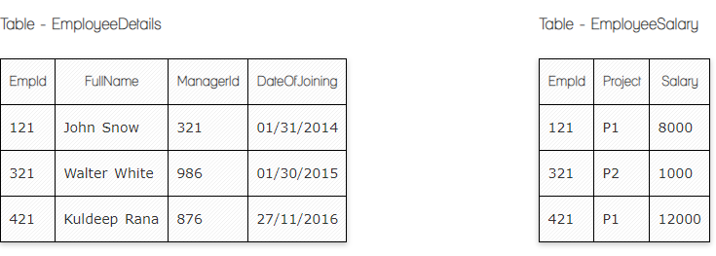

**Ques.1. Write a SQL query to fetch the count of employees working in project 'P1'.**

**Your Answer:**

**SELECT COUNT(EmpId),Project**

**FROM EmployeeSalary**

**GROUP BY Project**

**HAVING Project='P1'**

**Ques.2. Write a SQL query to fetch employee names having salary greater than or equal to 5000 and less than or equal 10000.**

**Your Answer:**

**SELECT EmployeeDetails.FullName,EmployeeSalary.Salary**

**FROM EmployeeDetails**

**INNER JOIN EmployeeSalary**

**ON EmployeeDetails.EmpId=EmployeeSalary.EmpId**

**WHERE Salary BETWEEN 5000 AND 10000**

**Ques.3. Write a SQL query to fetch count of employees sorted by project's count in descending order.**

**Your Answer:**

**SELECT COUNT(EmpId),Project**

**FROM EmployeeSalary**

**GROUP BY Project**

**ORDER BY COUNT(Project) DESC**

**Ques.4. Write a query to fetch employee names and salary records. Return employee details even if the salary record is not present for the employee.**

**Your Answer:**

**SELECT EmployeeDetails.FullName,EmployeeSalary.Salary**

**FROM EmployeeDetails AS ED**

**LEFT JOIN EmployeeSalary AS ES**

**ON ED.EmpId=ES.EmpId**

**Ques.5. Write a SQL query to create an empty table with ‘Test’ name.**

**Your Answer:**

**CREATE TABLE Test**

**Ques.6. Write a SQL query to delete an empty table with ‘Test’ name.**

**Your Answer:**

**DROP TABLE TEST**

**Ques.7. Write a SQL query to fetch all the Employees details from EmployeeDetails table who joined in Year 2016.**

**Your Answer:**

**SELECT \***

**FROM EmployeeDetails**

**WHERE DateOfJoining='2016'**

**OR**

**SELECT\***

**FROM EmployeeDetails**

**Where DateofJoing BETWEEN '01/01/2016' AND 12/31/2016'**

**Ques.8. Write a SQL query to insert new record to the EmployeeDetails table with any data.**

**Your Answer:**

**INSERT INTO EmployeeDetails()**

**Values ()**

**Ques.9. Write a SQL query to update EmployeeSalery table with setting Salary to 2000 for Project P2.**

**Your Answer:**

**UPDATE EmployeeSalary**

**SET Salary=2000**

**WHERE Project=’P2’**

**Ques.10. Write a SQL query to right join both tables and draw the results.**

**Your Answer:**

**SELECT \***

**FROM Employeedetails AS ED**

**RIGHT JOIN EmployeeSalary AS ES**

**ON ED.EmpId=ES.EmpId**

**Now take these two tables:**

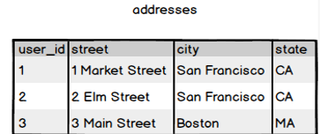

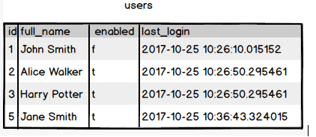

**Ques.11. Write a SQL query to fetch all users full_name from San Francisco.**

**Your Answer:**

**SELECT addresses.city,users.full_name**

**FROM addresses**

**INNER JOIN users**

**ON addresses.user_id=users.id**

**WHERE addresses.city=’San Francisco’**

**Ques.12. Write a SQL query to fetch all users full_name, last_login who are enabled**

**Your Answer:**

**SELECT full_name,last_login**

**FROM users**

**WHERE enabled=’t’**

**Ques.13. Write a SQL query to fetch all users full_name who are not from Main street**

**Your Answer:**

**SELECT users.full_name, address.street,**

**FROM users**

**INNER JOIN addresses**

**ON address.user_id=users.id**

**WHERE NOT addresses.street=”Main Street”**

**Ques.14. Write a SQL query to fetch all users full_name who are from Main street or San Francisco**

**Your Answer:**

**SELECT users.full_name, addresses.street,address.city**

**FROM users**

**INNER JOIN addresses AS Ad**

**ON Ad.user_id=users.id**

**WHERE Ad.city=”San Francisco” OR Ad.street=”Main Street”**

**Ques.15. Write a SQL query to fetch user full_name who is equal to user_id from Boston (find user_id value in sub_query)**

**Your Answer:**

**SELECT full_name**

**FROM users**

**WHERE user_id=**

**(SELECT user_id**

**FROM addresses**

**WHERE city=”Boston” )**